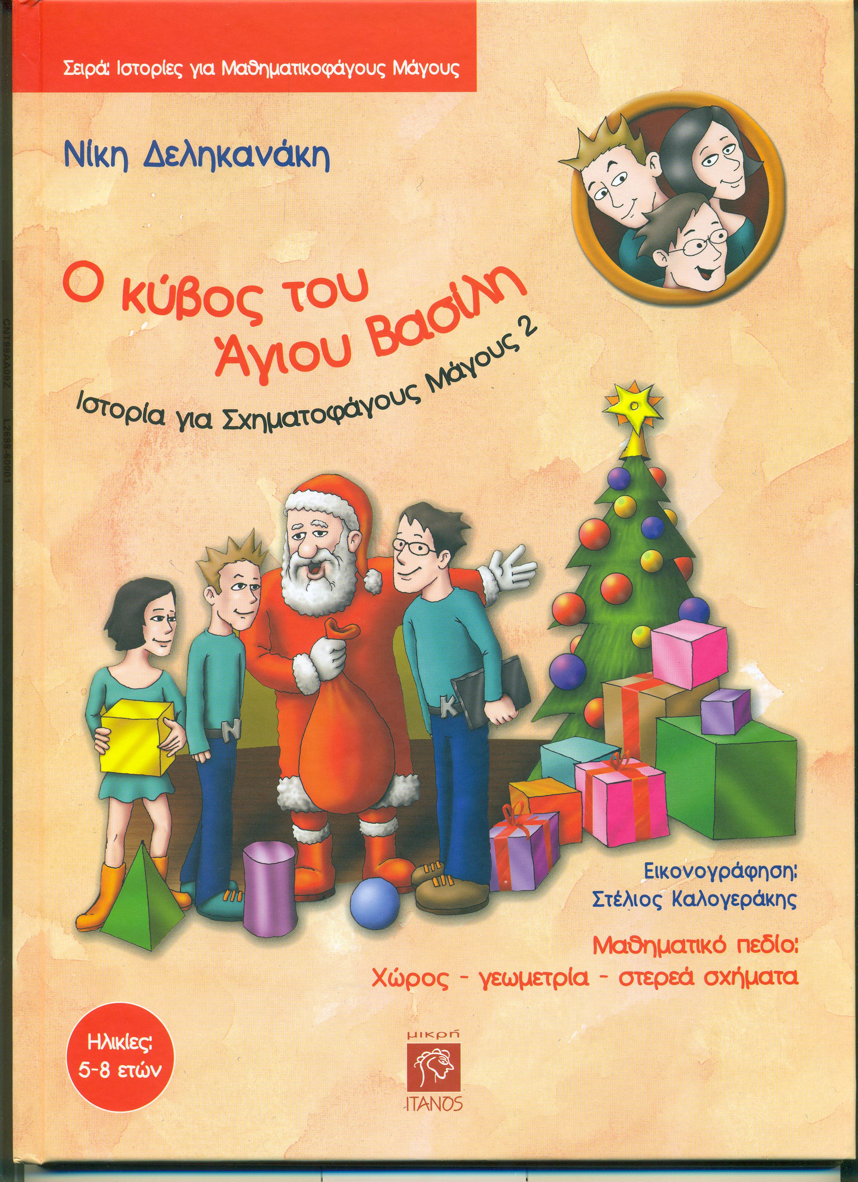
MATHEMATICAL LITTERATURE
Series: Stories for Mathematics-Magicians
Title: The Santa Claus’ Cube (Story 2)
Author: Niki Delikanaki *
Ilustr.: Stelios Kalogerakis (www.kalogerakis.org)
Description: book, for children of 5-8 years old, edited in 2010, Iraklion, Greece, copyright: Niki Delikanaki, size 29x21cm, 40pages, language greek, accompanied with transdisciplinary activities in webpage: www.delikanaki.gr ISBN: 978-960-7549-52-5
*Niki Delikanaki, Phd of the Education School of University of Ioannina, is the State Consultant of the 19th Region of Preschool Education, in Iraklio, Greece, Researcher in Preschool Maths and early screening of cognitive disorders.
Related Dimensions of the book
Mathematics: Geometry, cube
-Knowledge of the solid
-Surface area of a cube
-Other geometric solids
Cross-thematic text: Language goals
-Christmas wishes (spelling, vocabulary)
-Opposite words, Synthesis of words
-Riddle: the metaphor in the use of language
-instruction’s text illustrated(p.34)

Universal values, attitudes to nurture
Solidarity: help someone…
Courage: save through danger…
Knowledge is a powerful weapon against evil…
Diversity: every one of us is near to a hobgoblin…
Spirit of Christmas and wishes for the good, the fairness, etc.
Methodology: of contemporary Mathematics and Cognitive Development
The cross-thematic text supports the mathematical goals, which are being emerged from a text that has a crucial meaning for the children.
Additionally, the writer uses the method of posing a problem, that can mobilize many neuropsychological cognitive procedures, trying to attain the solution.
Metacognition strategies integrate child’s cognitive development, as they can realize and explain their procedure of thinking, by the meaningful use of “written message: instructions of making a cube…”( page 35)

